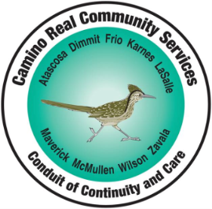
Camino Real Community Services
19965 F.M. 3175 North, P.O. Box 725, Lytle, TX 78052

Phone: (210) 357-0300 Fax: (210) 357-0450
Relay Texas: (800) 735-2989 (TTY) Crisis Hotline: (800) 543-5750

=======================================================================================

APPLICATION FOR PNAC COMMITTEE MEMBERSHIP

PLEASE PRINT

Name: Home Telephone:

Home Address, City, State, Zip:

E-Mail Address: FAX Number:

Occupation (Current or Former): Retired Employed

Business Address, City, State, Zip:

Business Telephone: Cell Phone:

I am applying for membership to the Camino Real Community Services Planning and Network Advisory Committee (PNAC). It is required that 50% of the PNAC membership be current or former consumers (or family members of consumers) of adults or children with mental illness, intellectual or developmental delays and disabilities.

Do you meet these criteria? Yes No

If so, which? Mental Illness Intellectual Disabilities Developmental Disability

PNAC Meetings are scheduled on a quarterly basis.
Would you be able to commit to attending four (4) meetings a year? Yes No

Transportation Needs: I can transport myself to the meetings and have my mileage reimbursed.
(Check all that apply.) I will need assistance from Camino Real Community Services in getting to the meetings.
I am willing to coordinate travel with other PNAC Committee members or staff to be able to get to the meetings.
Other (Specify):

Are you, or any immediate relative, currently under contract with Camino Real Community
Services as a provider of any goods or services? Yes No

Are you, or any immediate relative, in an occupation that could directly financially benefit from
decisions made by the PNAC Committee for which you are seeking membership? Yes No

Applicant Signature
Date

